GE 2

CA Scene

<http://www.youtube.com/watch?v=uvFc0EPRSI4>

Entities:

* Jet 1 -> Maverick
* Jet 2 -> Iceman
* Jet 3 -> MIG1 (enemy)
* Jet 4 -> MIG2 (enemy)
* Jet 5 -> MIG3 (enemy)
* Jet 6 -> MIG4 (enemy)

Start

Camera starts off like this:

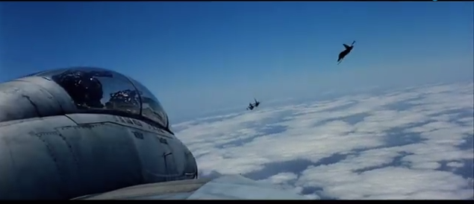

Maverick -> MIG1 -> Iceman

Iceman

* Wander with larger radius
  + Jet is trying to avoid being locked on

MIG1

* Pursue Iceman
  + Trying to get a lock on to fire machine gun

Maverick

* Pursue MIG 1

-------------------------------------------------------

Switch to cut scene

-------------------------------------------------------

Switch camera to cockpit view of MIG 1

After 5-10 seconds MIG 1 fires machine gun at Iceman and hits some shots

-------------------------------------------------------

Switch to cut scene

-------------------------------------------------------

Iceman still in wander for about 10 seconds

Camera switch to top down view

Iceman banks hard right ->include voice from video

MIG same

Maverick same

Pursue continues, Maverick fires missile but misses

After another 10 seconds maverick fires second missile and hits MIG1

MIG 1 explodes

-------------------------------------------------------

Switch to cut scene

-------------------------------------------------------

Iceman slows down and elevates

Maverick banks left softly

-------------------------------------------------------

Switch to cut scene

-------------------------------------------------------

MIG 2 appears on mavericks tale and pursue begins

Camera:

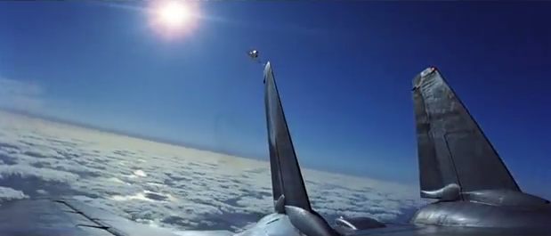

MIG 2 fires machine gun

Maverick does barrel role

-------------------------------------------------------

Switch to cut scene

-------------------------------------------------------

Maverick slows down to bring MIG 2 in closer

MIG 2 enters offset pursue

After MIG 2 reaches offset Maverick hits breaks to preform a TOPGUN manovour

MIG 2 behavior changes to wander

After MIG 2 is X distance in front of maverick, mavericks behavior changes to pursue.

Camera:

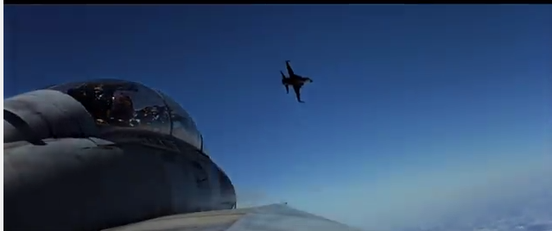

Mavericks locks on and fires missile. BOOM big explosion

Maverick continues wander for about 5 seconds.

---

Cut in music

---

MIG 3 and MIG 4 retreat -> wander out of FOV of camera to far left side of maverick.

-------------------------------------------------------

Switch to cut scene

-------------------------------------------------------

